**Assignment 2 – Mininet Topology Analysis**

**Ajinkya Gadgil**

**801200445**

1. Script file **topology.py** the file can be found in the submitted zip file
2. Output

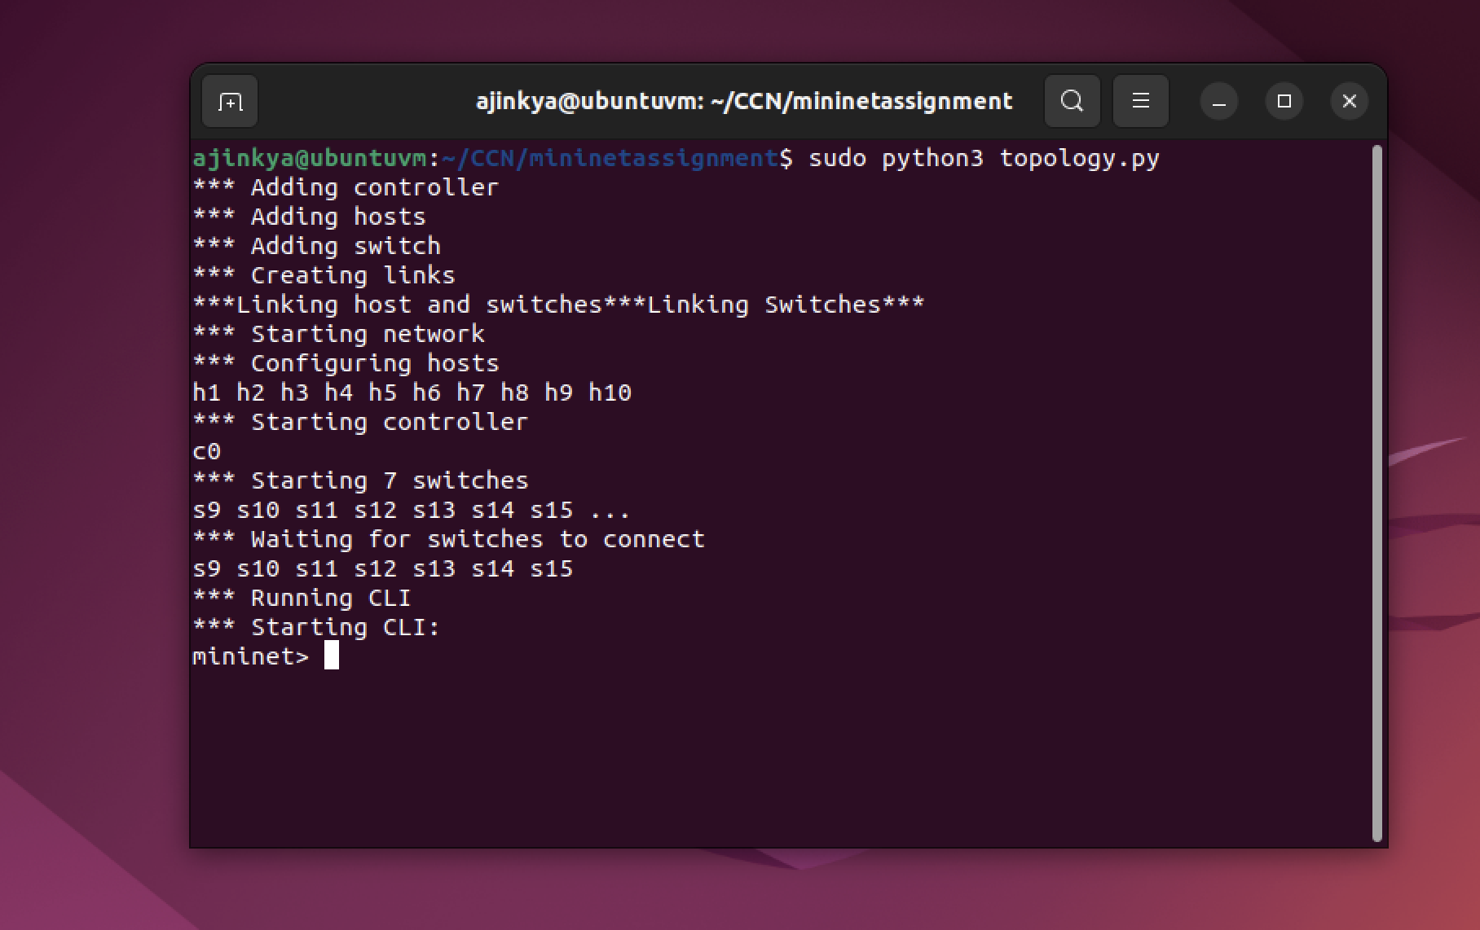

Python Code:

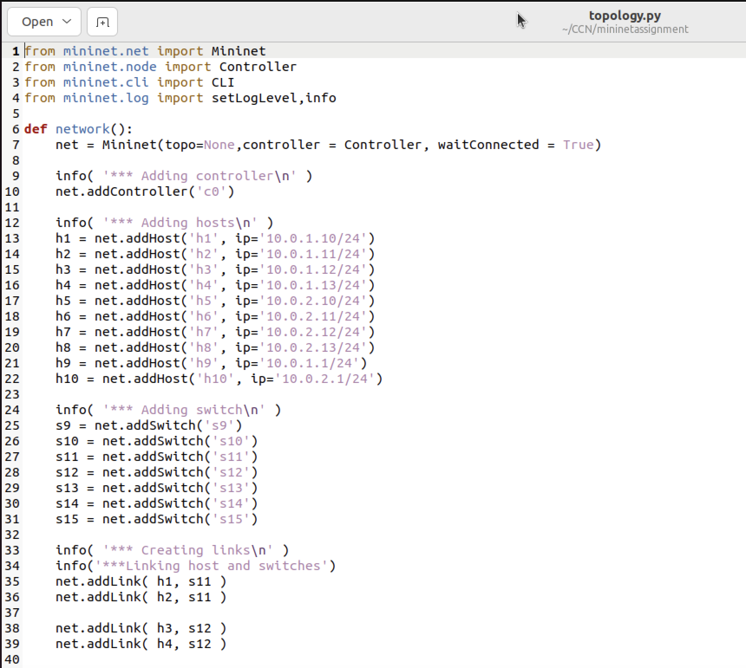

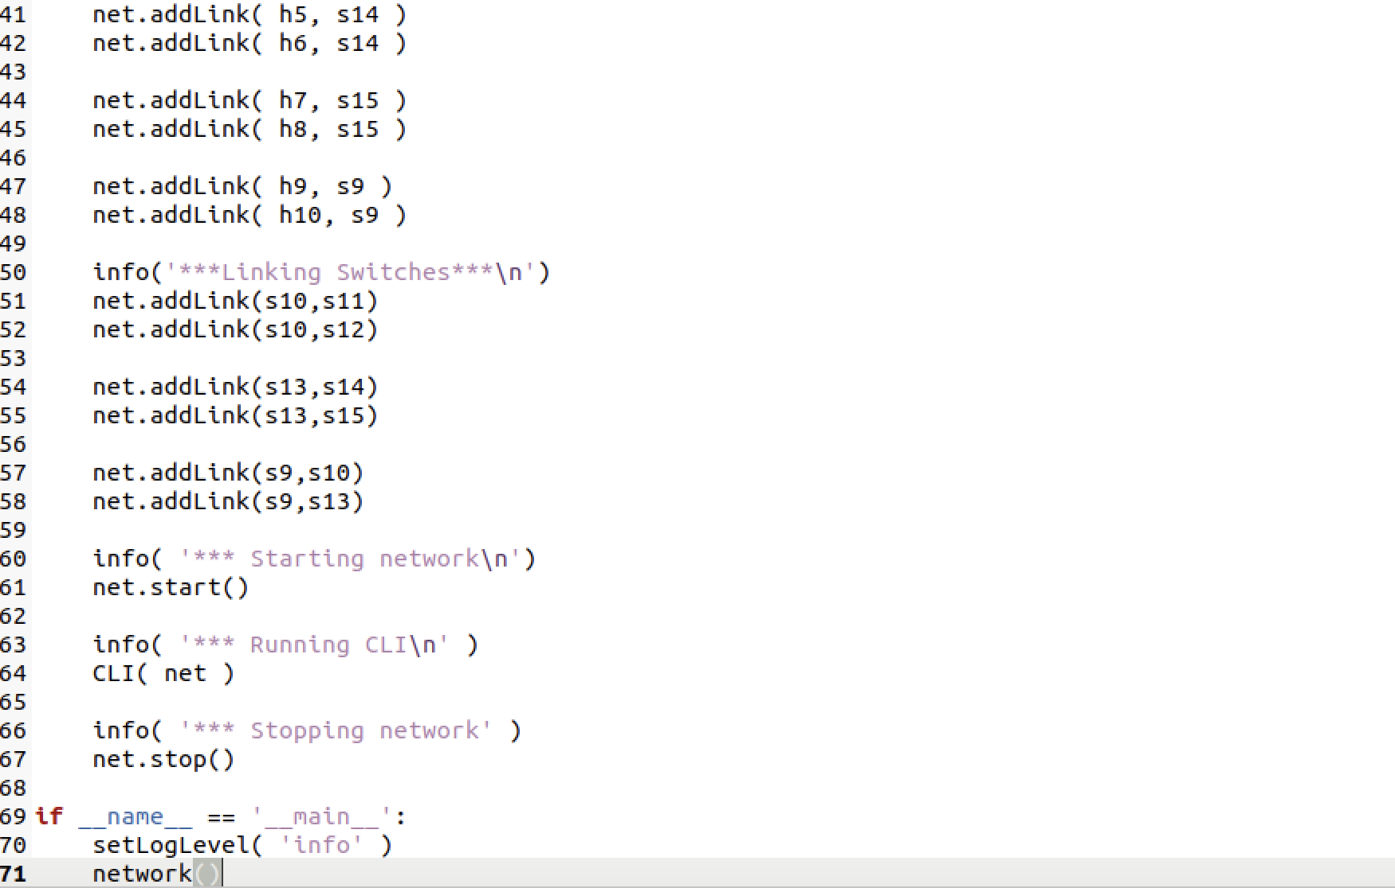

1. Pingall command output

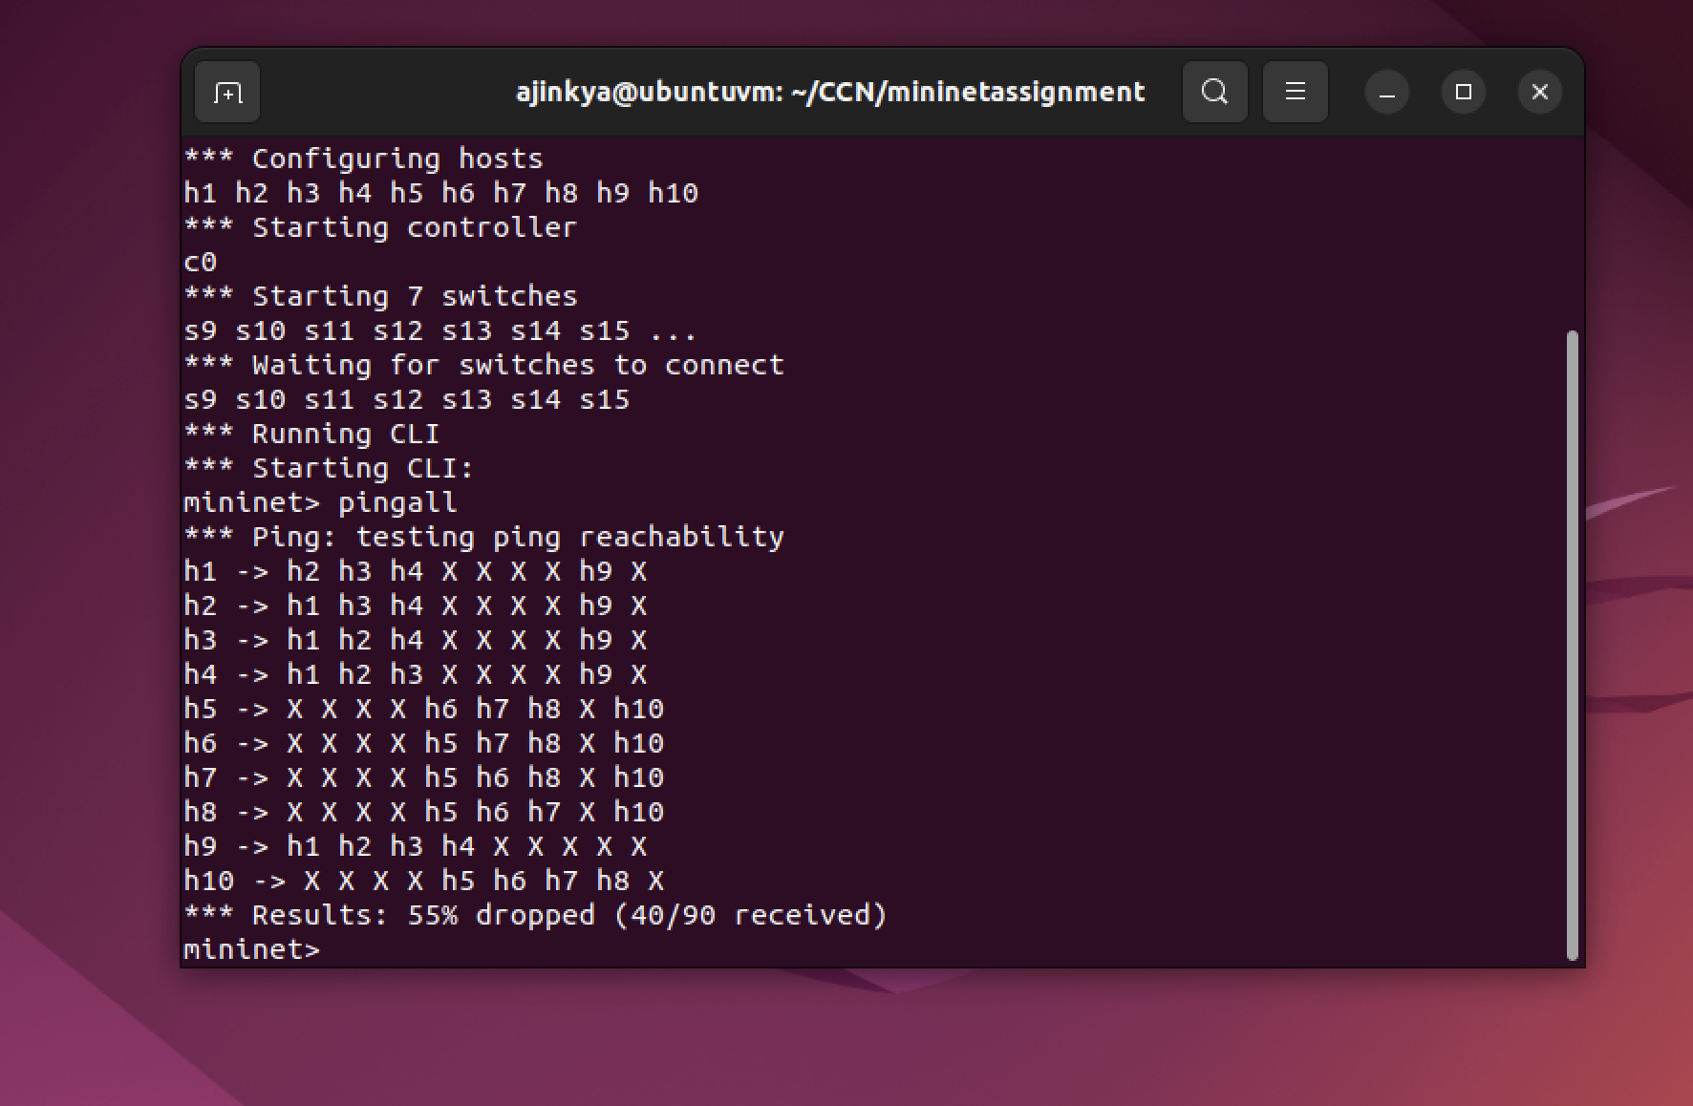

1. Table for scenario 1 and 2

**Scenario 1:**

**H9 -> H1:**

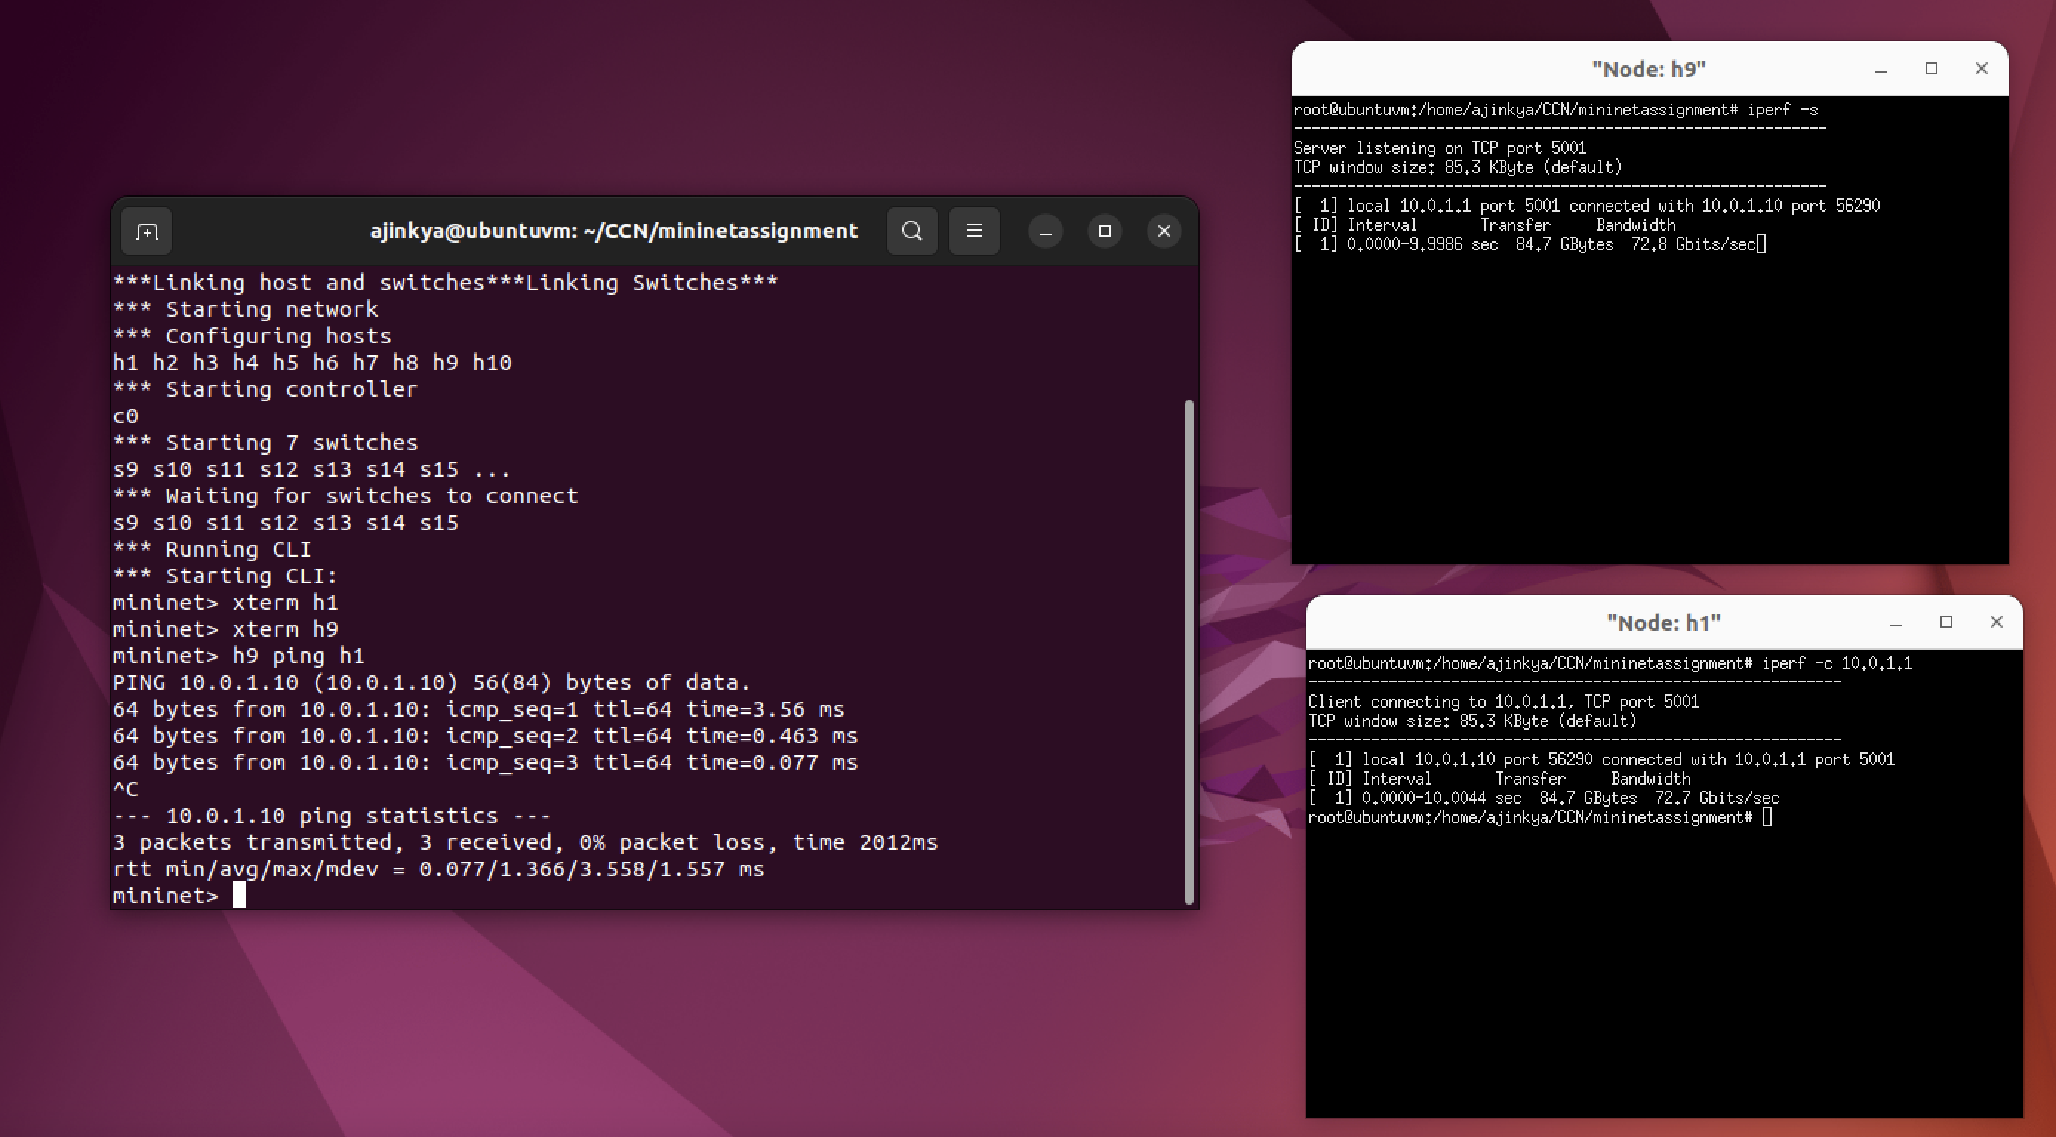

**H9 -> H2**

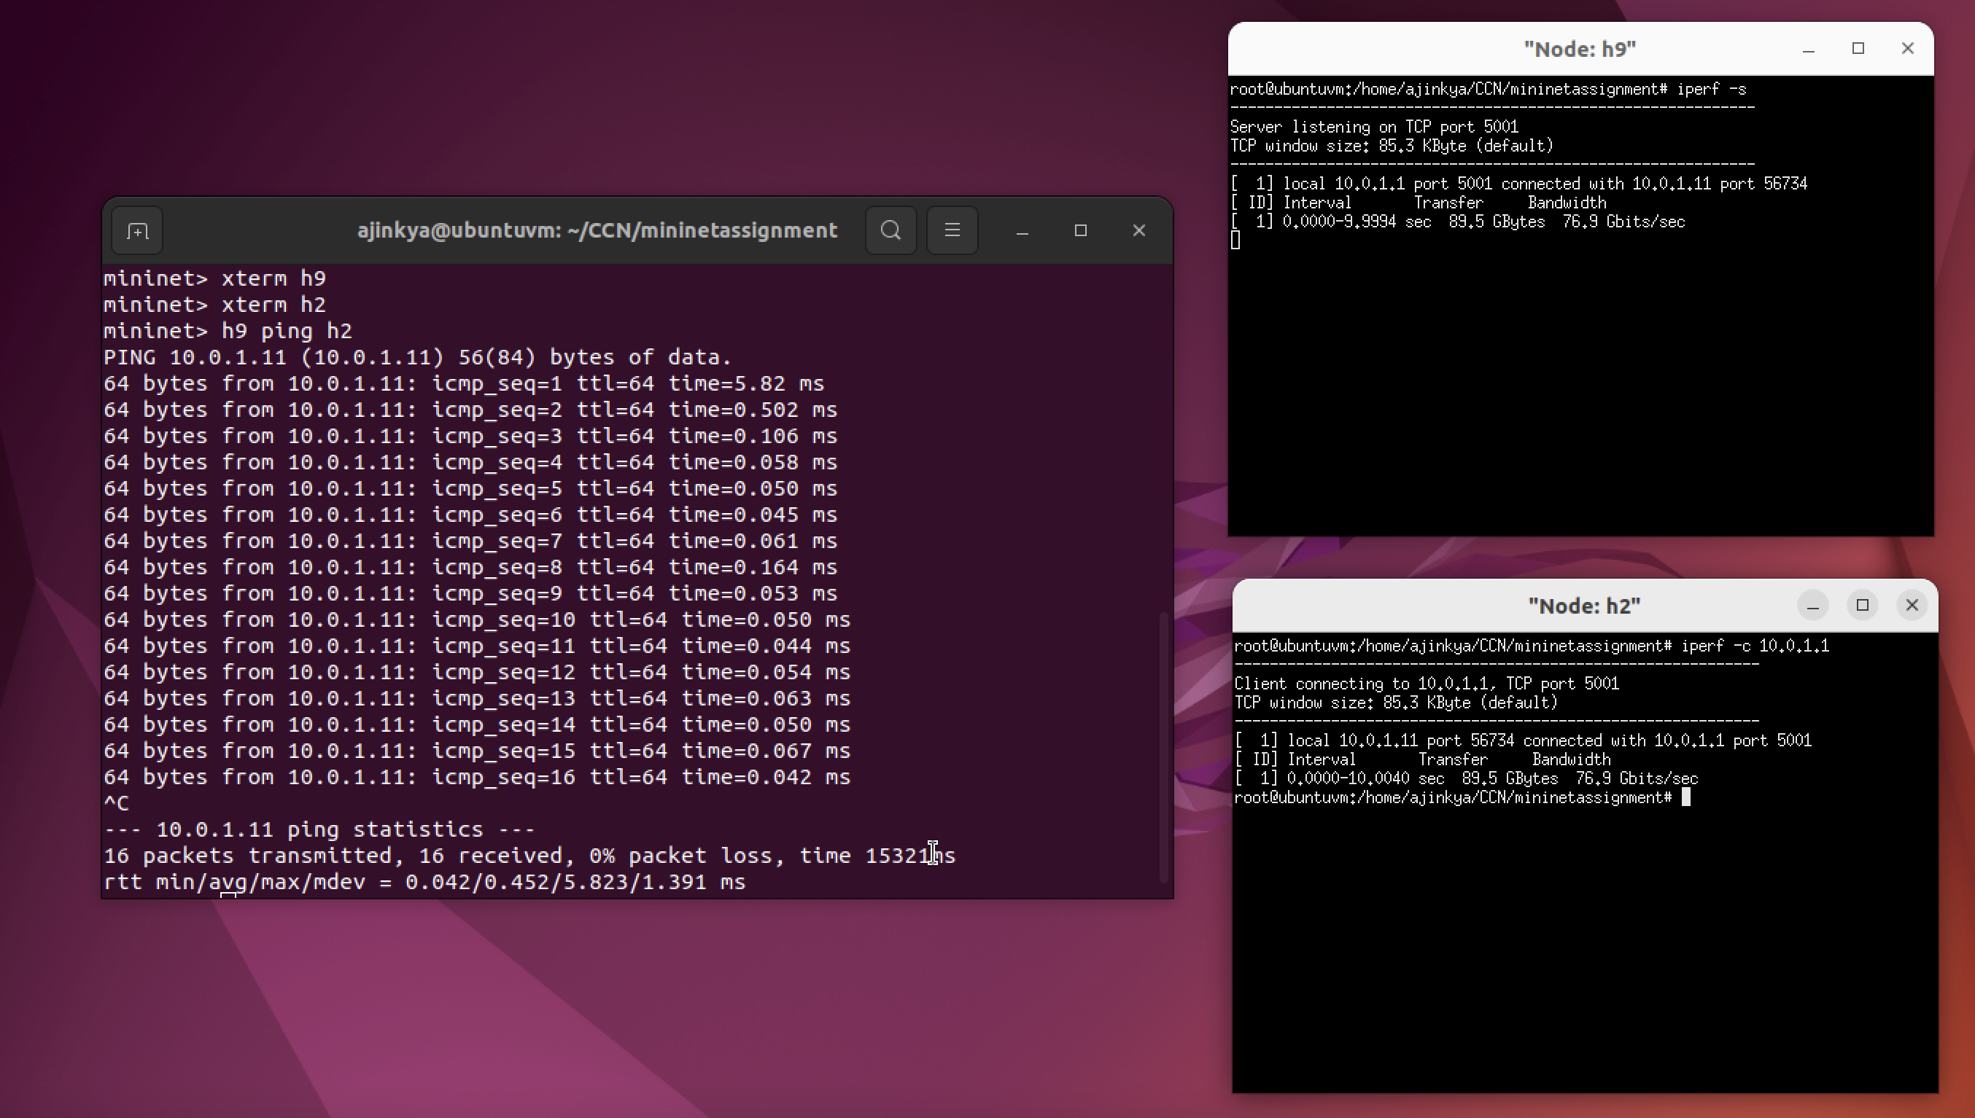

**H9 -> H3**

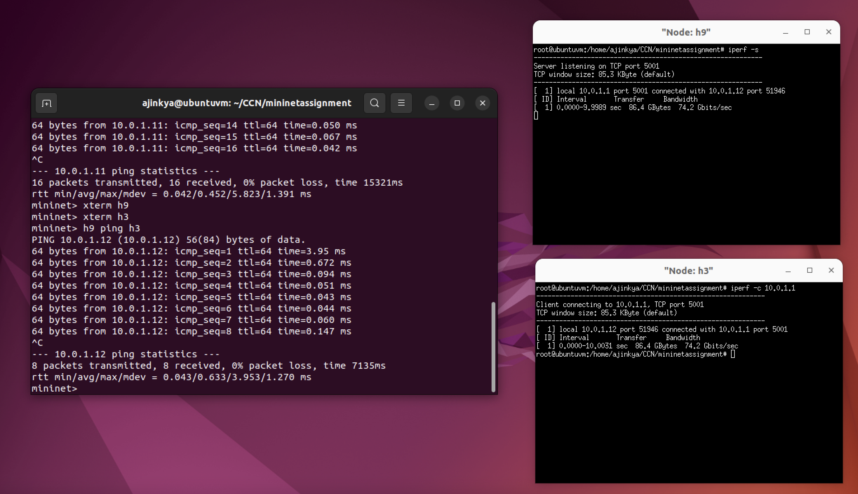

**H9 -> H4**

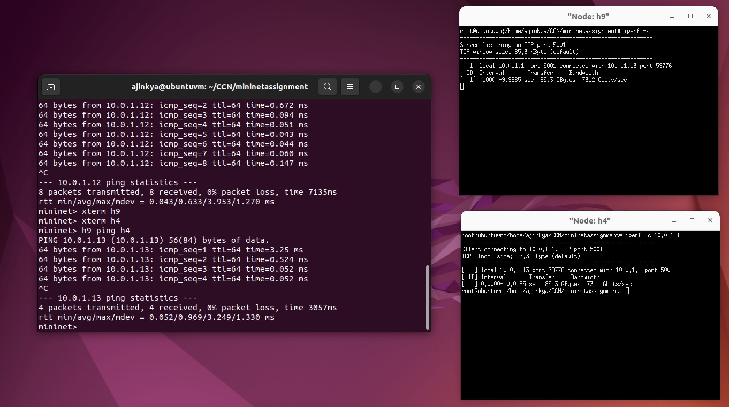

**H9 -> H5**

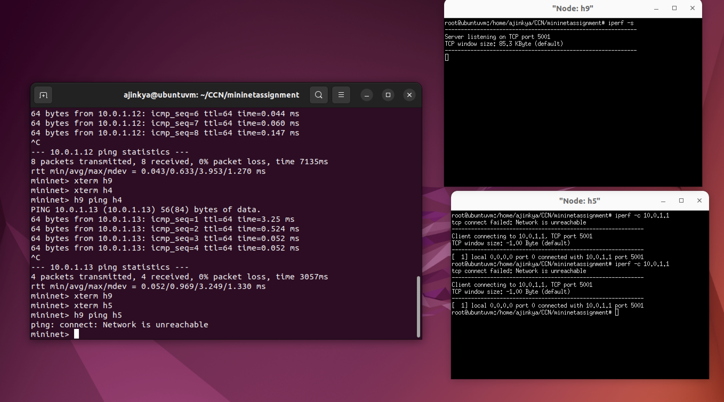

**H9 -> H6**

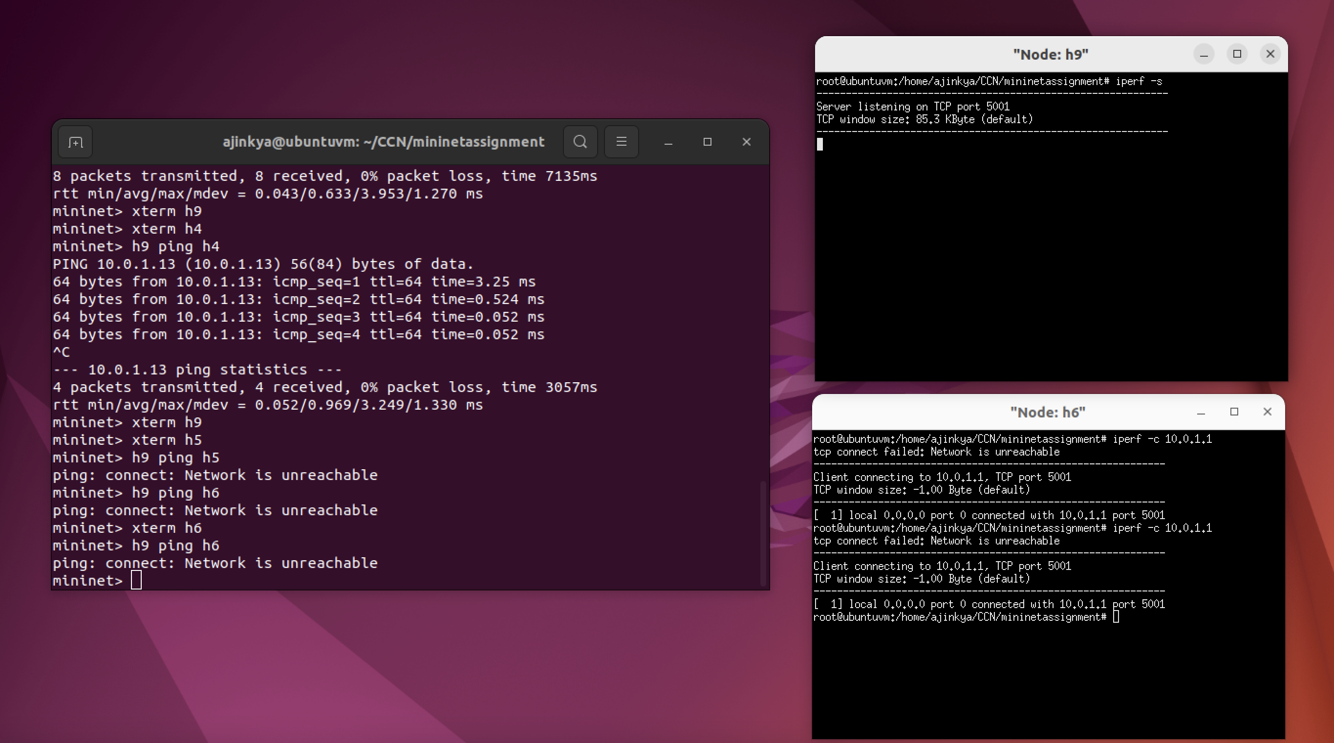

**H9 -> H7**

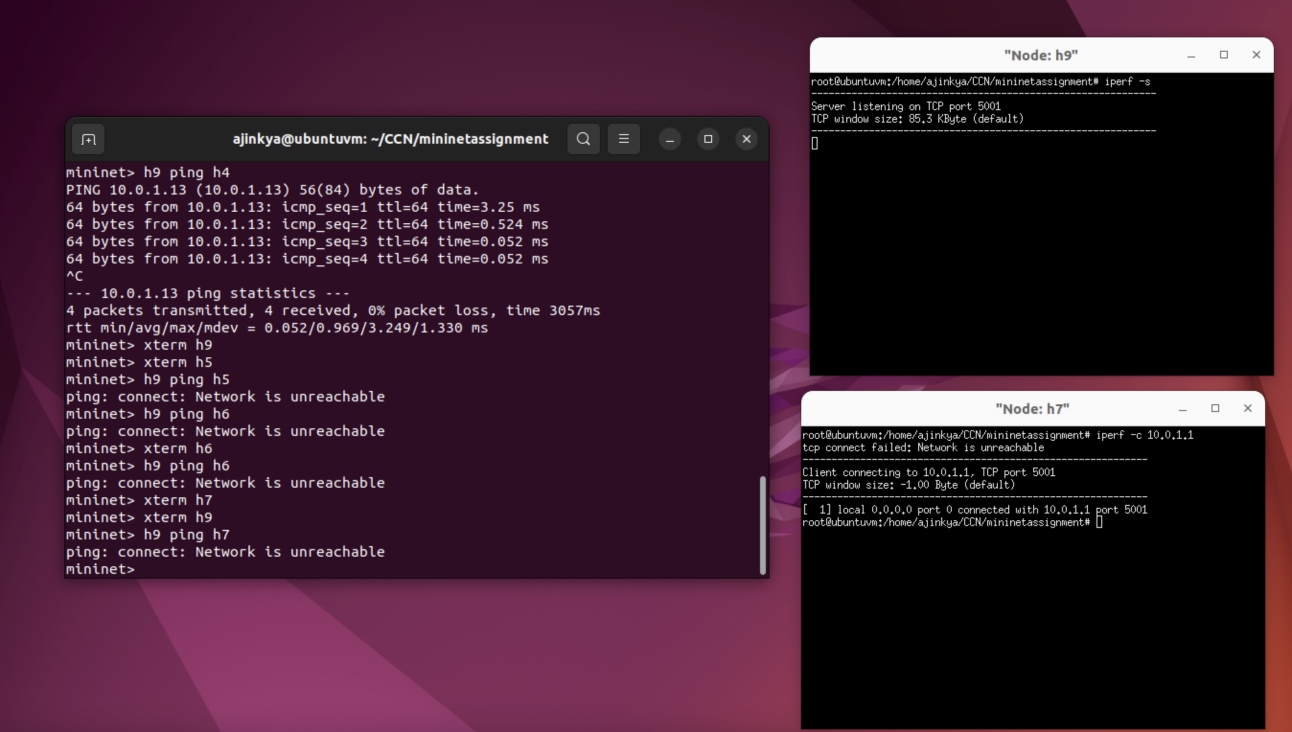

**H9 -> H8**

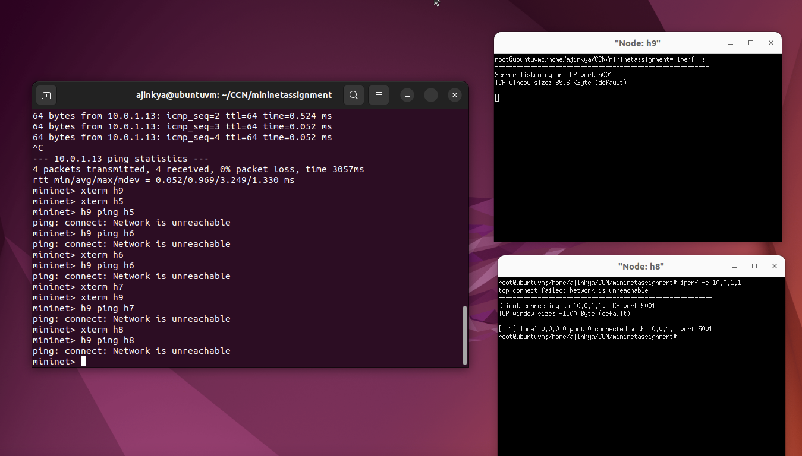

**H9 -> H9:**

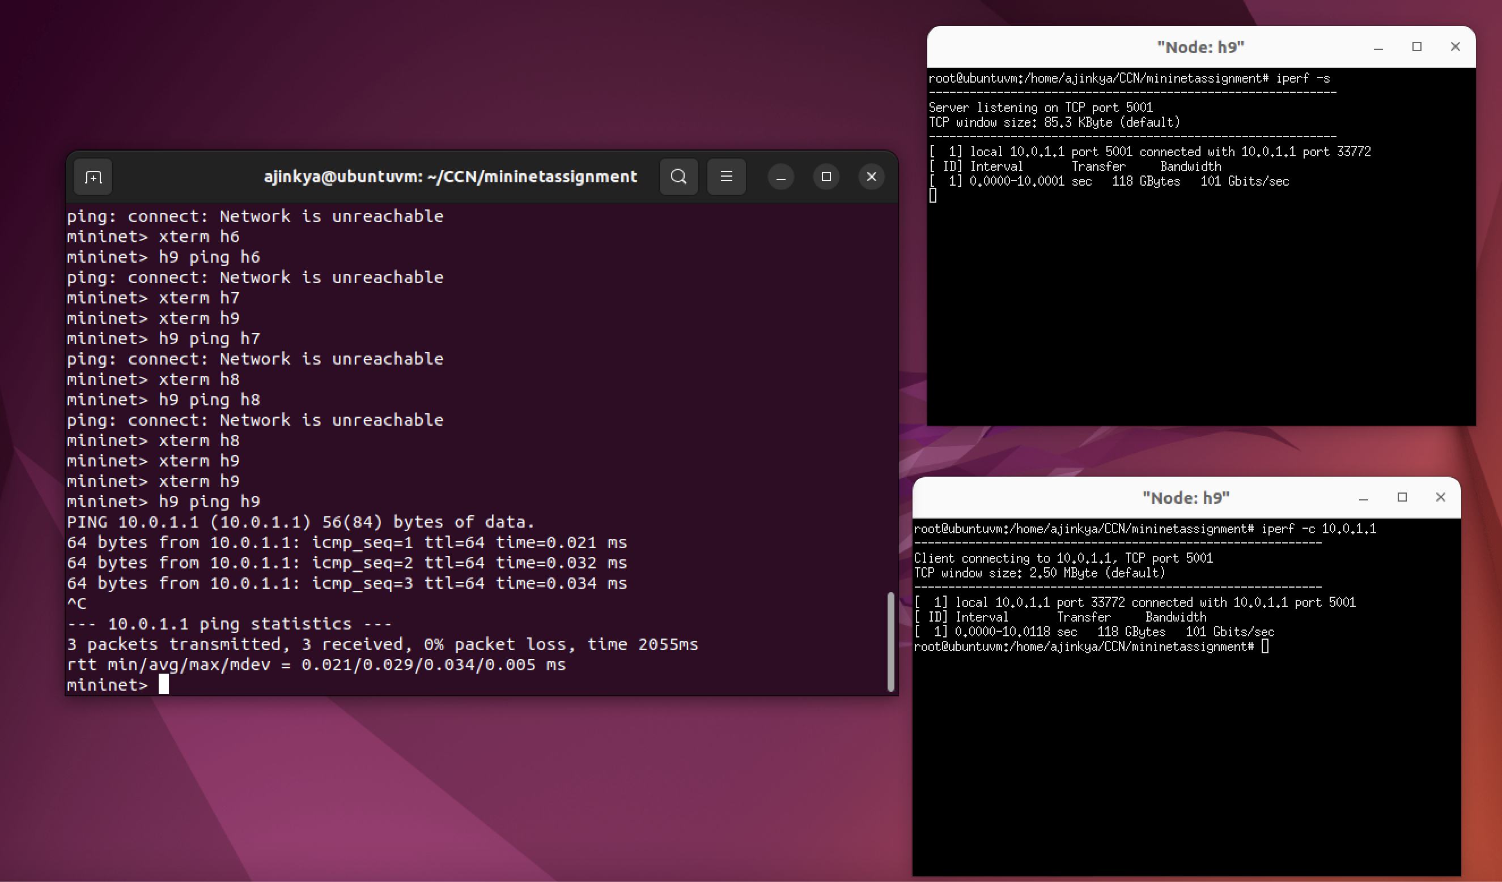

**H9 -> H10:**

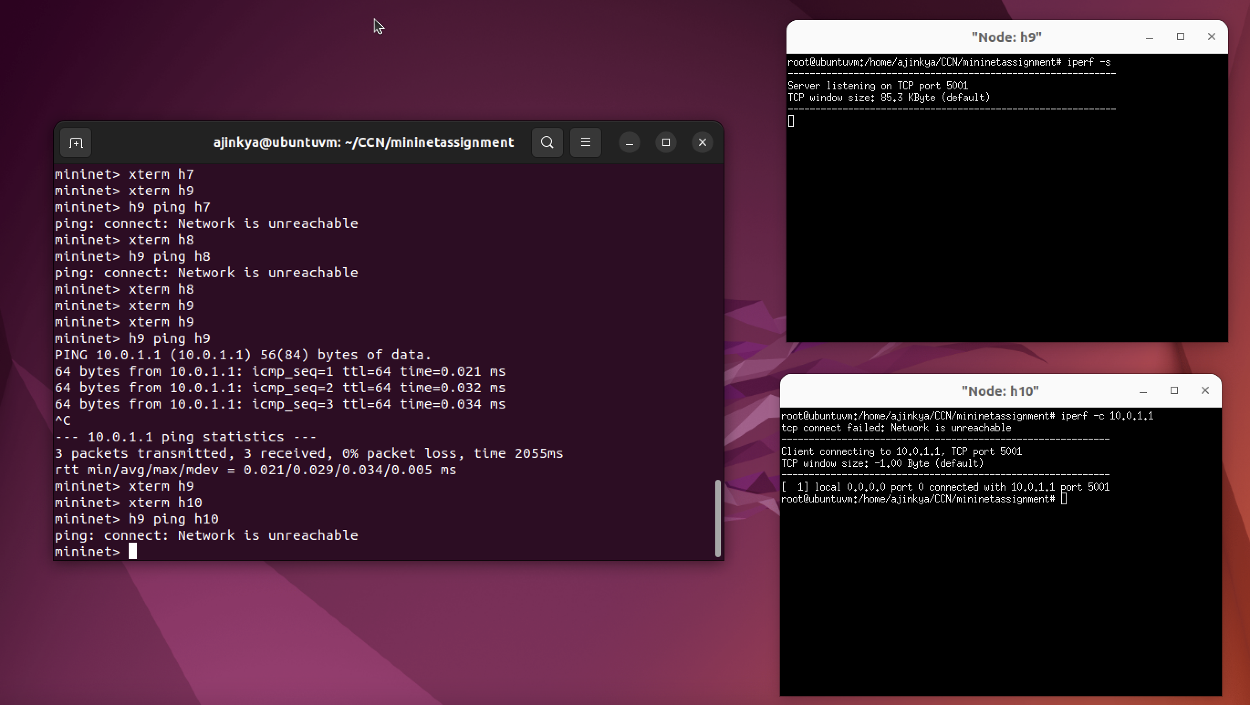

**Scenario 2:**

**H10 -> H1**

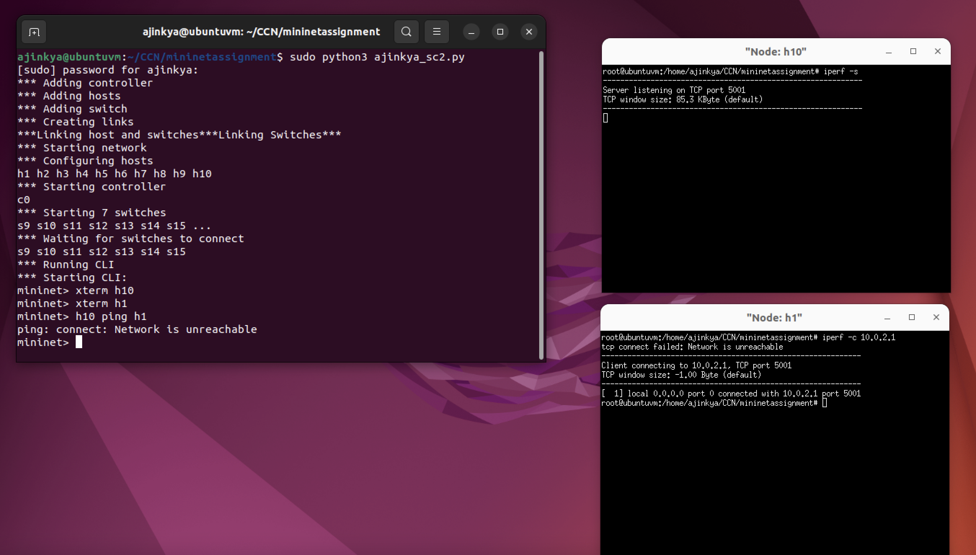

**H10 -> H2:**

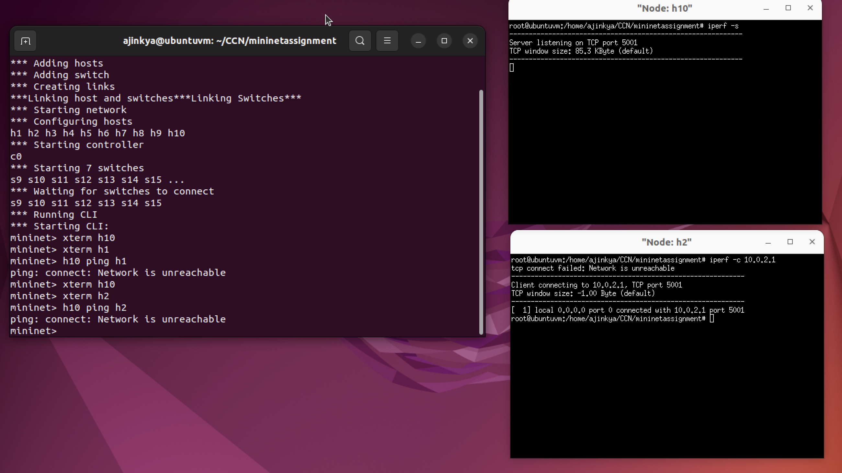

**H10 -> H3**

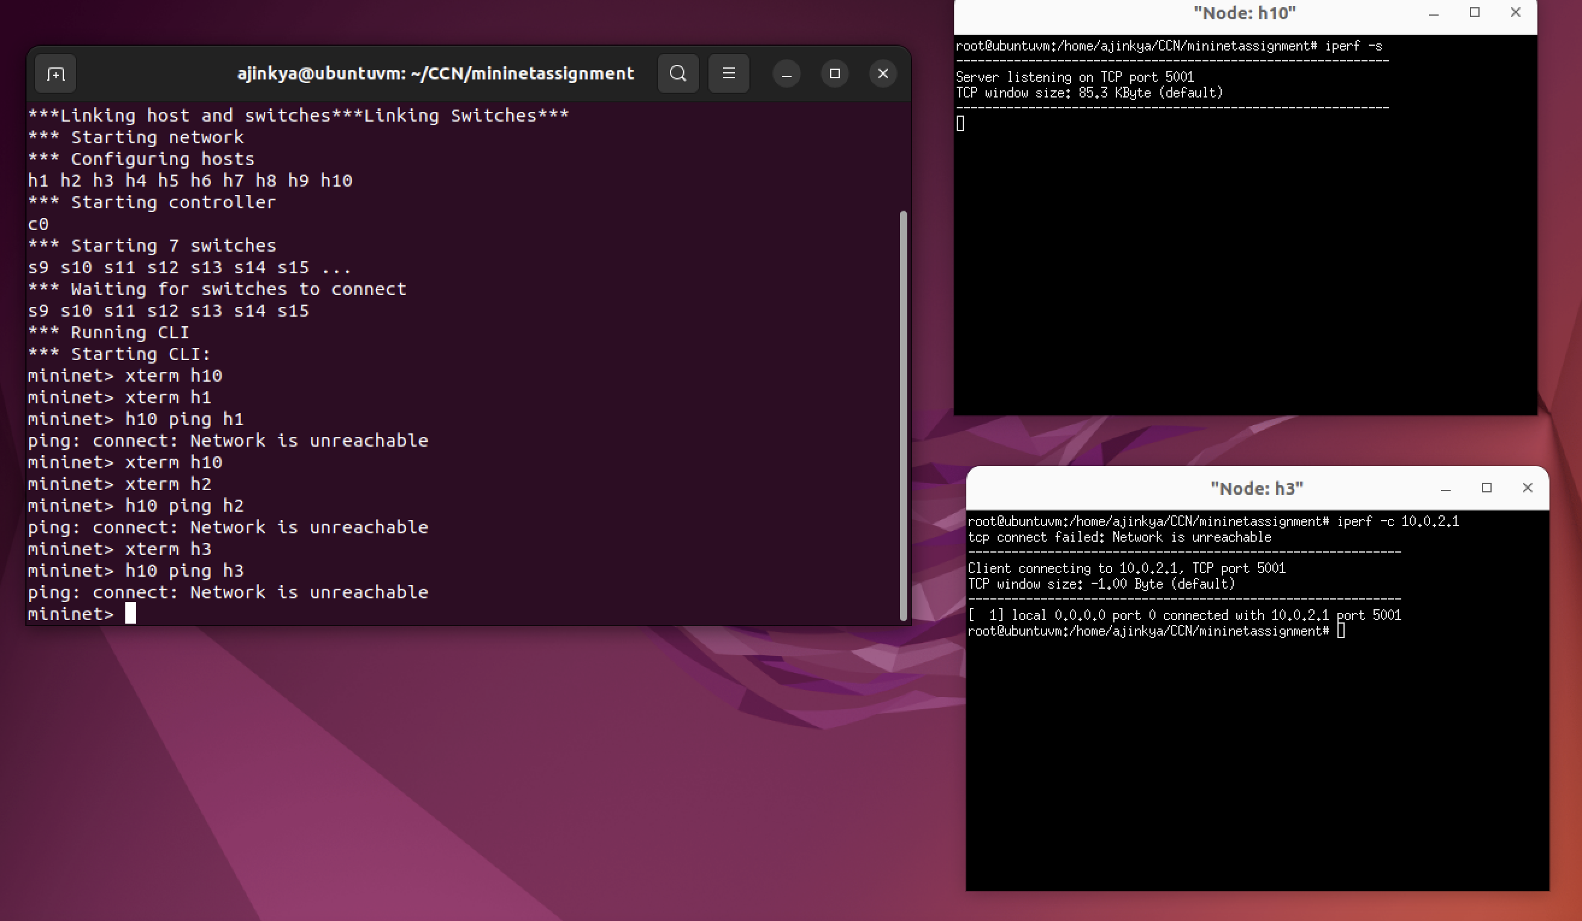

**H10 -> H4**

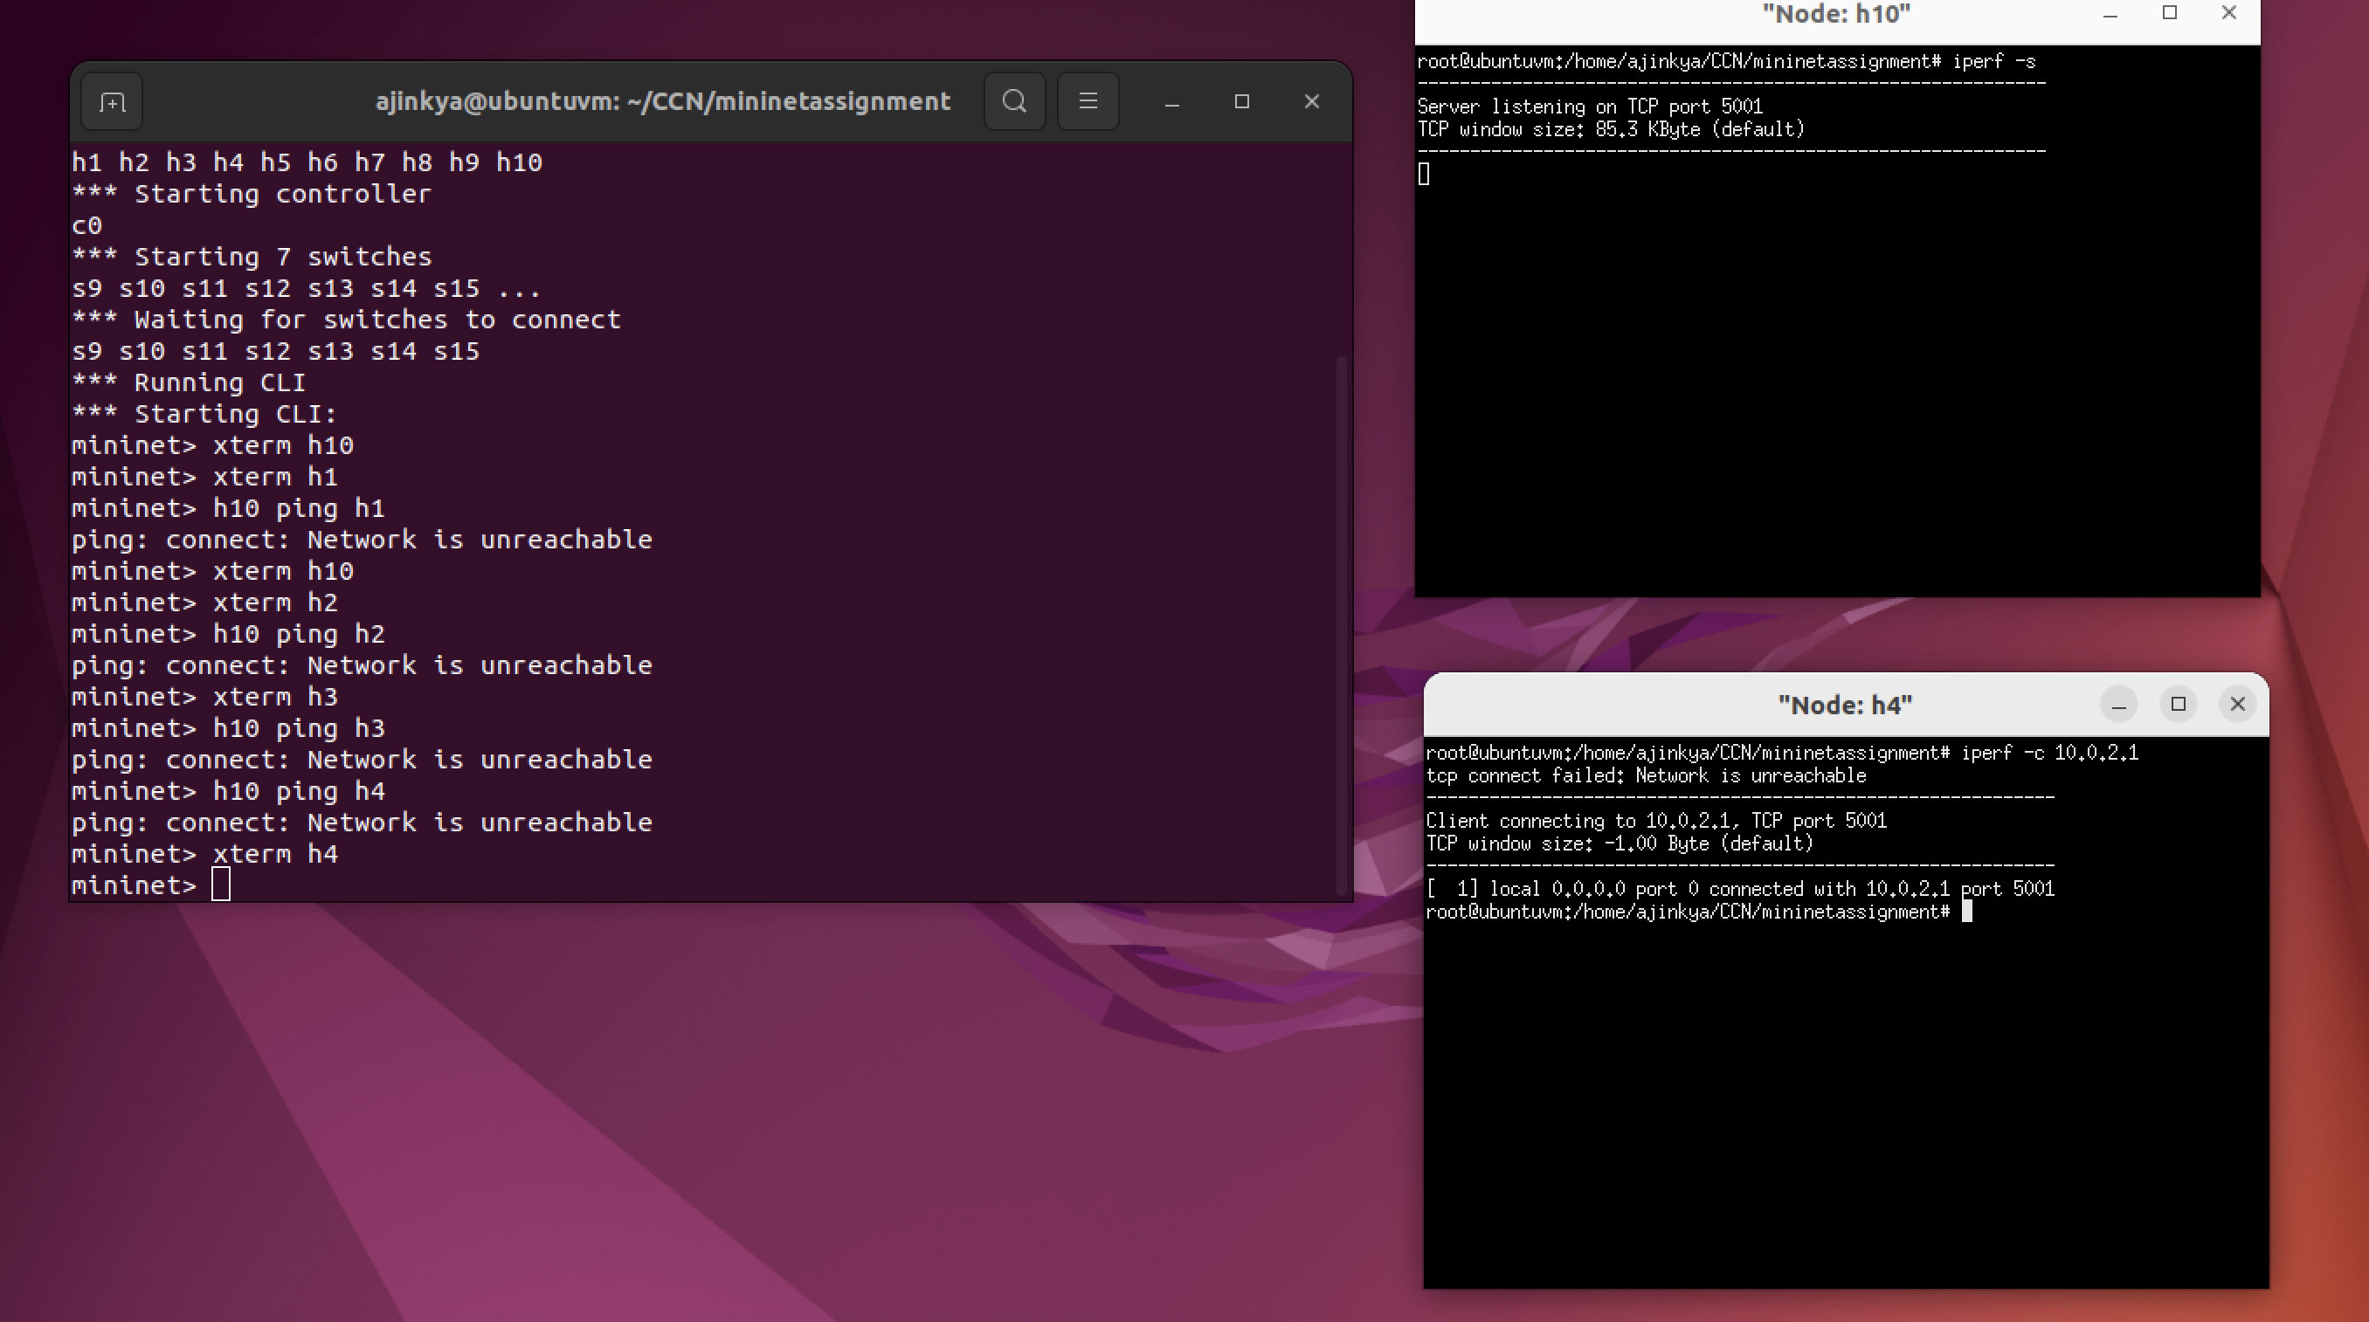

**H10 -> H5**

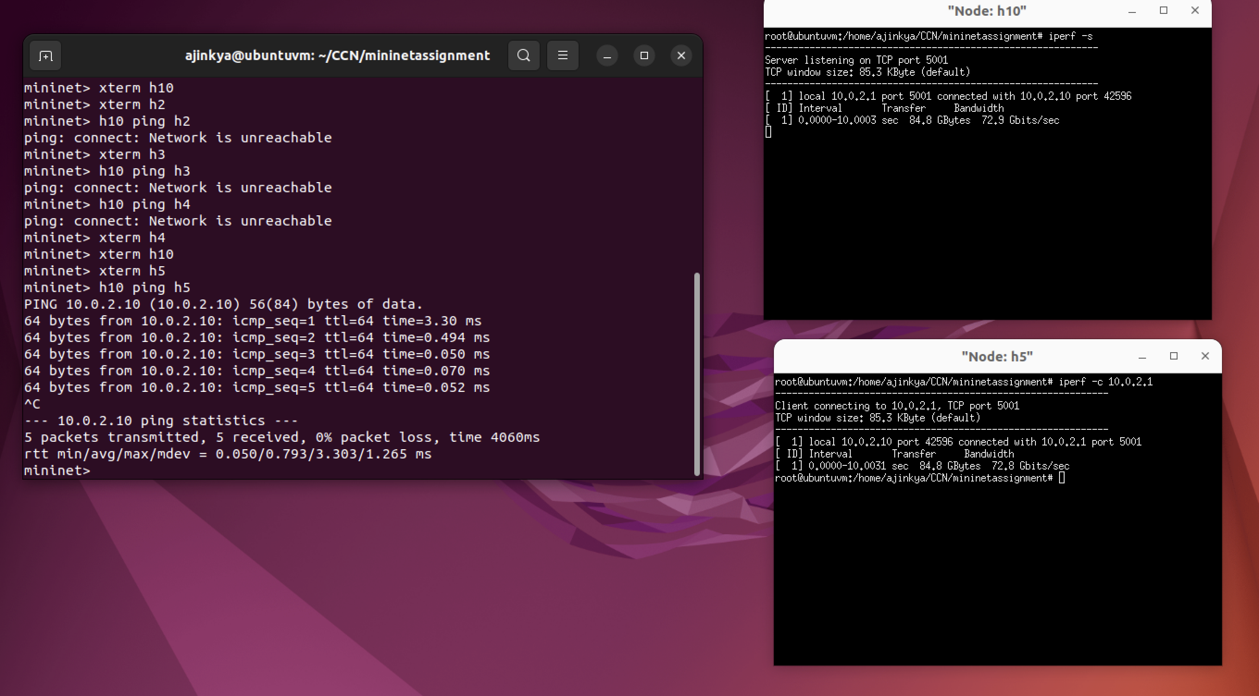

**H10->H6**

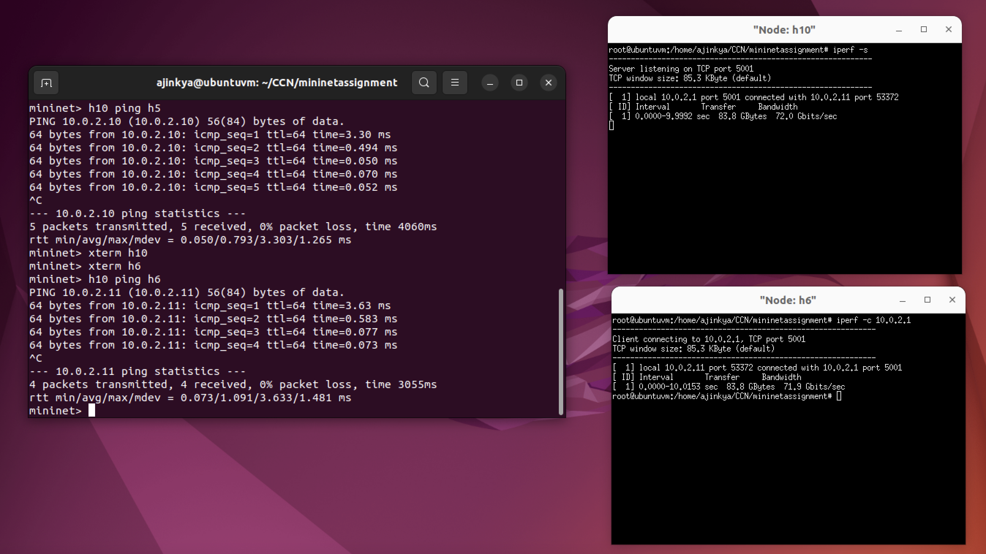

**H10 -> H7**

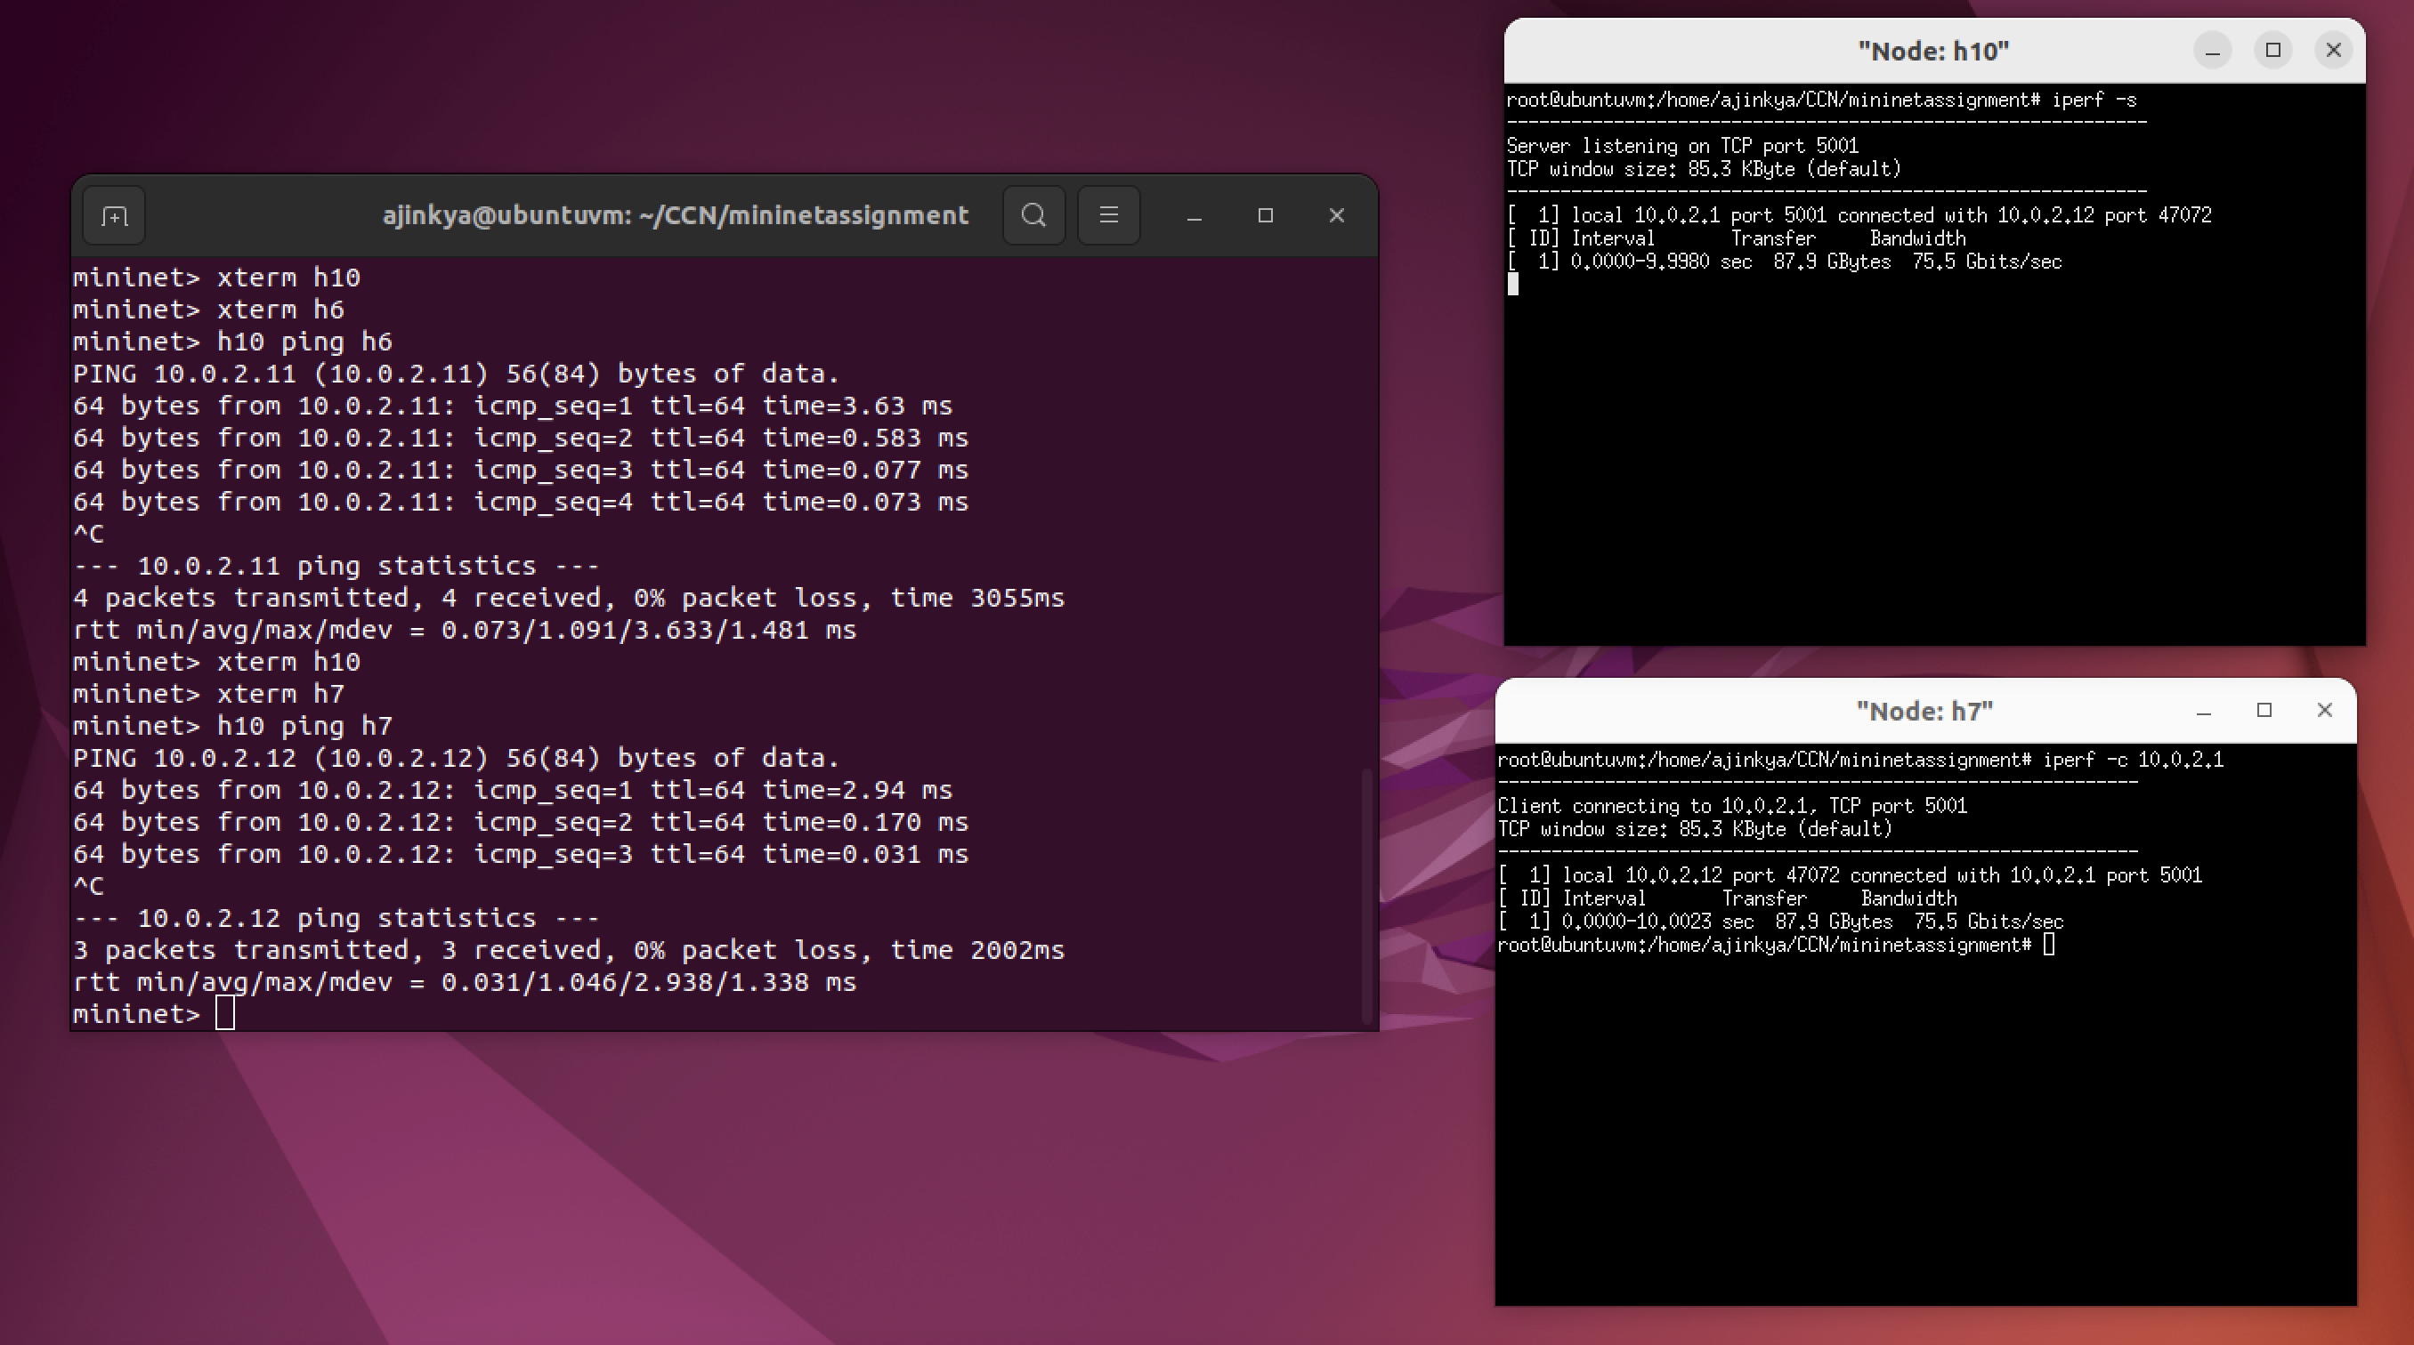

**H10 -> H8**

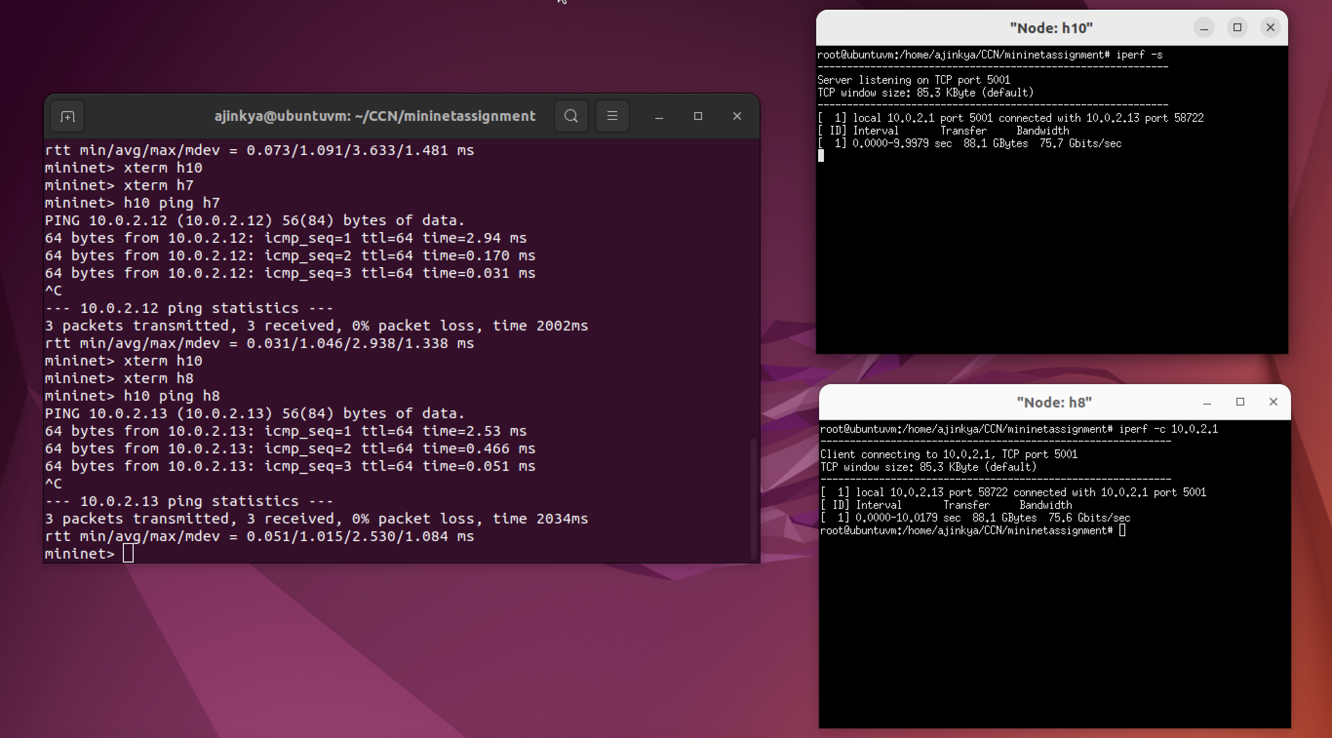

**H10 -> H9**

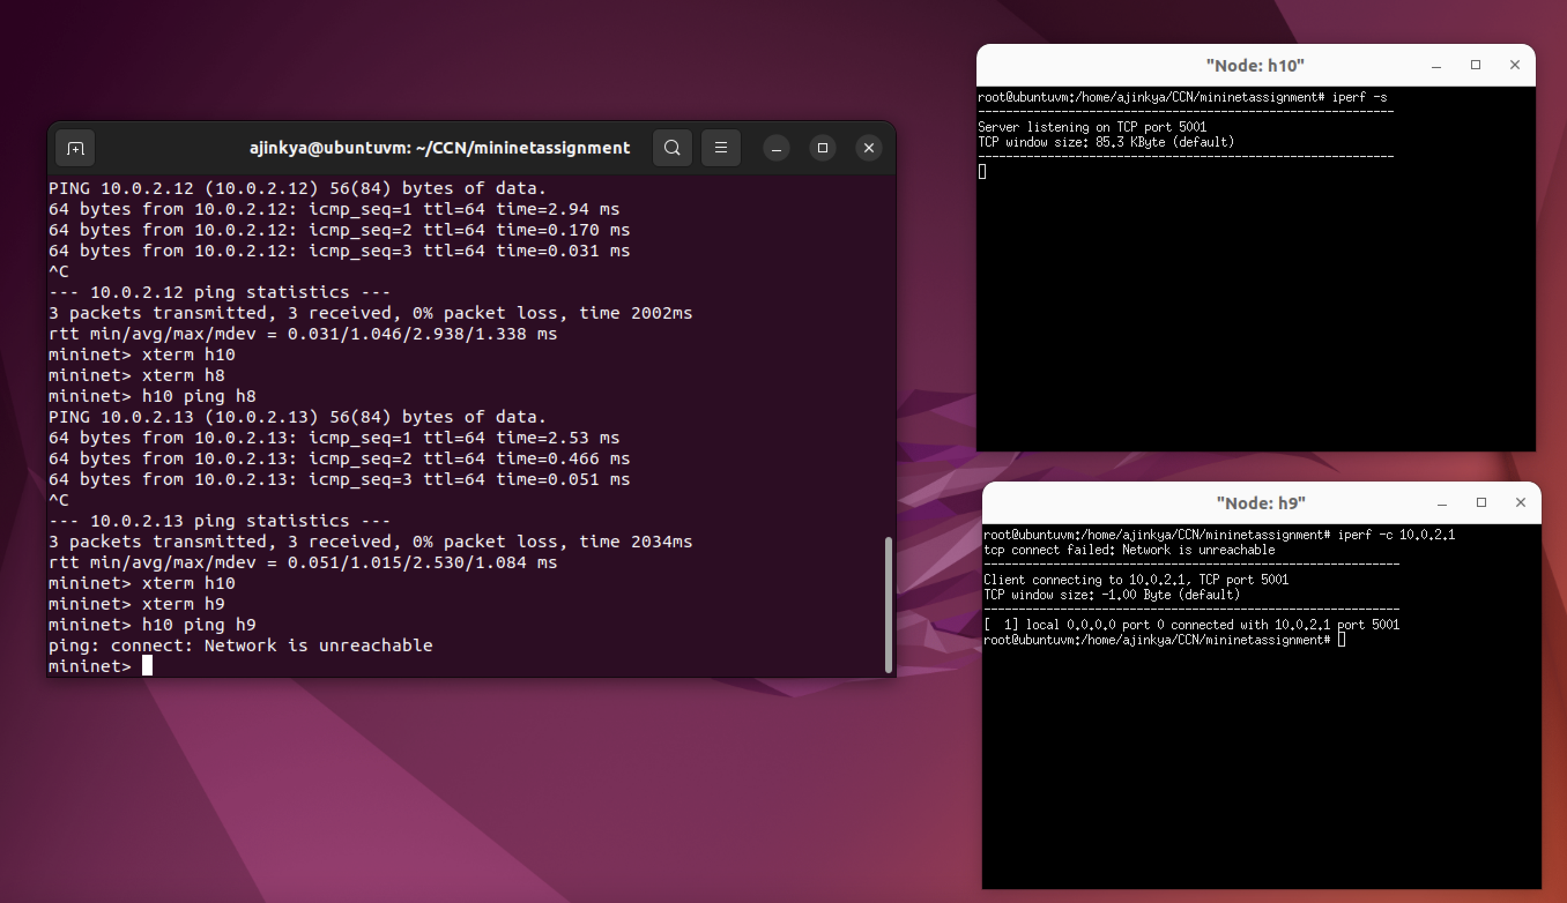

**H10 -> H10**

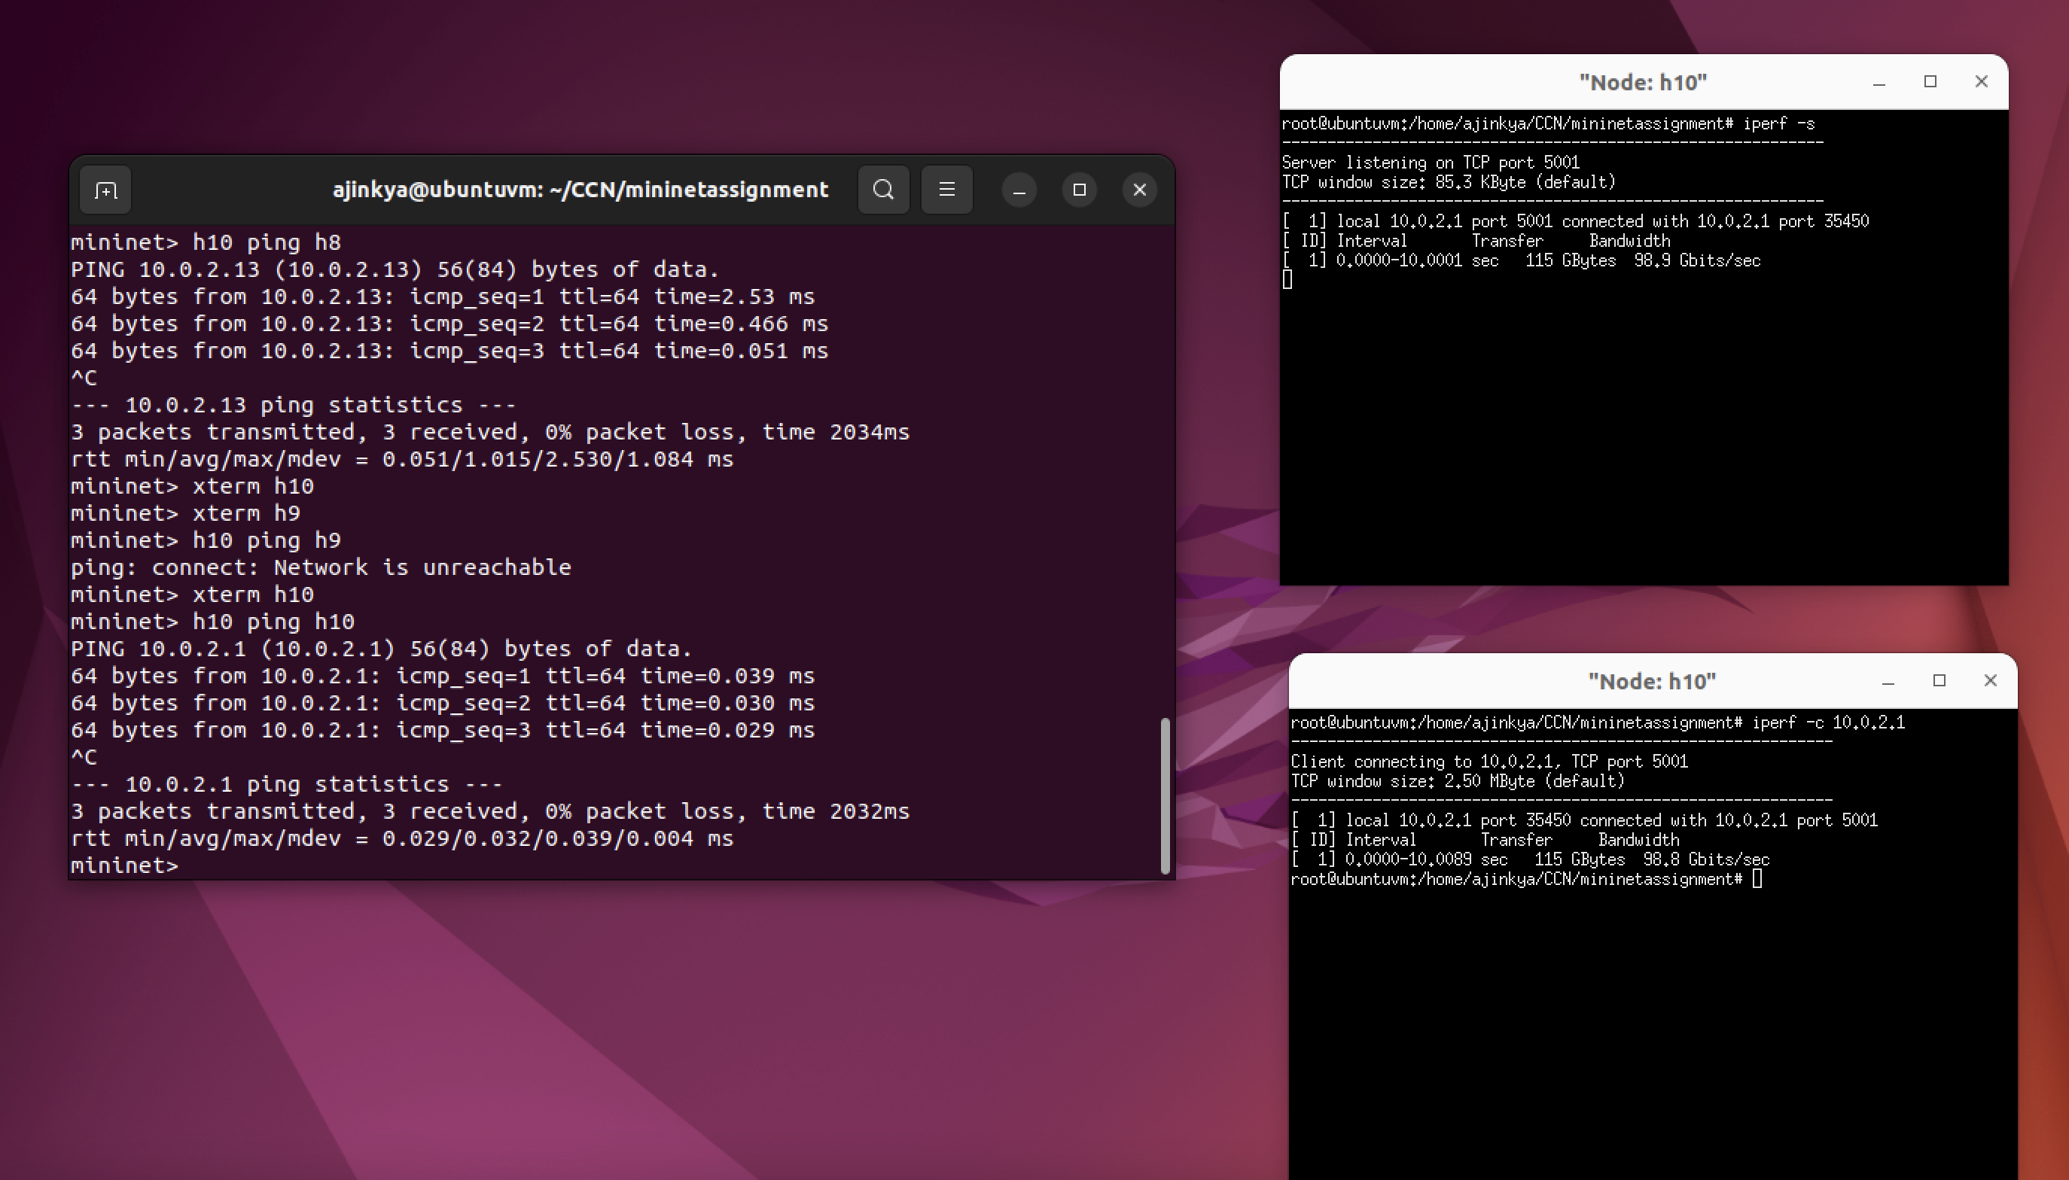

|  |  |  |  |  |  |
| --- | --- | --- | --- | --- | --- |
| Host | IP address | Is this host pingable from h9? | Is this host pingable from h10? | Scenario: 1  Measure bw and delay using iperf on H9 | Scenario: 2  Measure bw and delay using iperf on H10 |
| H1 | 10.0.1.10 | Yes | No | Bandwidth: 72.8Gbits/sec  Delay: 3.56ms | Unreachable |
| H2 | 10.0.1.11 | Yes | No | Bandwidth: 76.9Gbits/sec  Delay: 5.82ms | Unreachable |
| H3 | 10.0.1.12 | Yes | No | Bandwidth: 74.2Gbits/sec  Delay: 3.95ms | Unreachable |
| H4 | 10.0.1.13 | Yes | No | Bandwidth: 73.2Gbits/sec  Delay: 3.25ms | Unreachable |
| H5 | 10.0.2.10 | No | Yes | Unreachable | Bandwidth: 72.9Gbits/sec  Delay: 3.30ms |
| H6 | 10.0.2.11 | No | Yes | Unreachable | Bandwidth: 72.0Gbits/sec  Delay: 3.63ms |
| H7 | 10.0.2.12 | No | Yes | Unreachable | Bandwidth: 75.5Gbits/sec  Delay: 2.94ms |
| H8 | 10.0.2.13 | No | Yes | Unreachable | Bandwidth: 75.7Gbits/sec  Delay: 2.53ms |
| H9 | 10.0.1.1 | Yes | No | Bandwidth: 101Gbits/sec  Delay: 0.021ms | Unreachable |
| H10 | 10.0.2.1 | No | - | Unreachable | Bandwidth: 98.9Gbits/sec  Delay: 0.039ms |

1. H9 is in subnet1 and H10 is in subnet 2 hence H1 cannot reach H10 or H6 cannot reach H9. It is similar to many other nodes. This is marked as unreachable in the above table.